- Create one VPC in N. Virginia region.
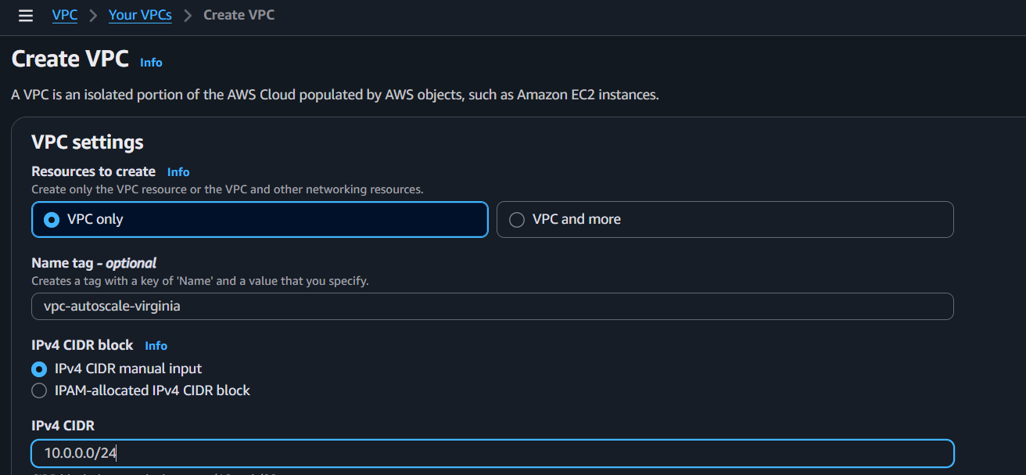
- Create two subnets: one public subnet and one private subnet.
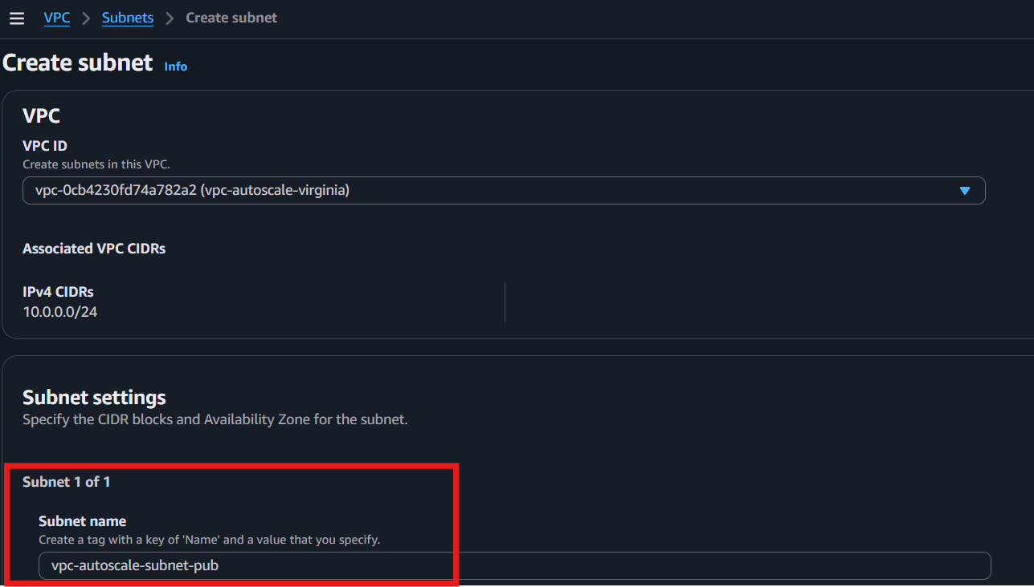
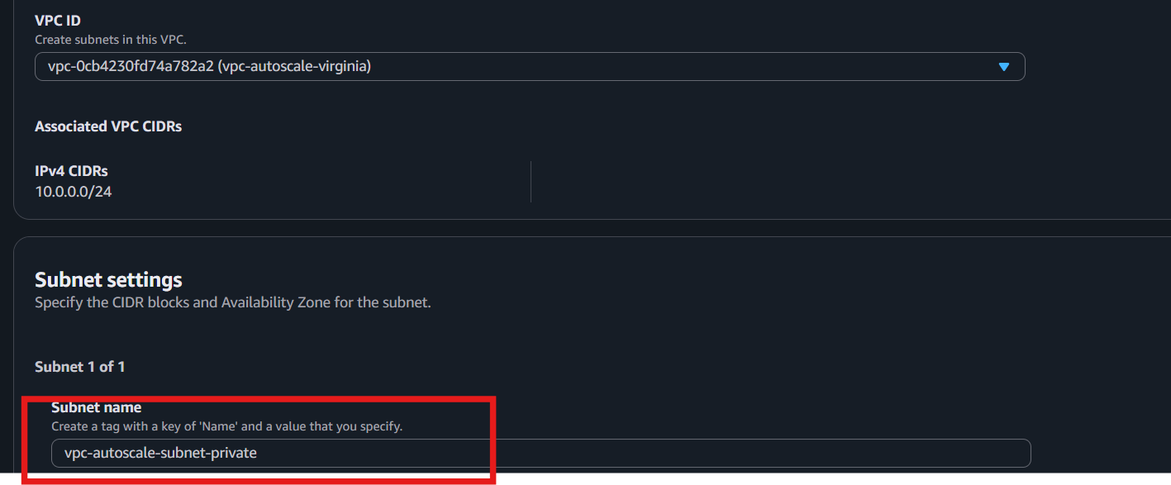
- Attach an IGW to the VPC.
- Go to VPC → Internet Gateways.
- Click Create internet gateway.
- Enter a name (e.g., My-IGW).
- Click Create internet gateway.
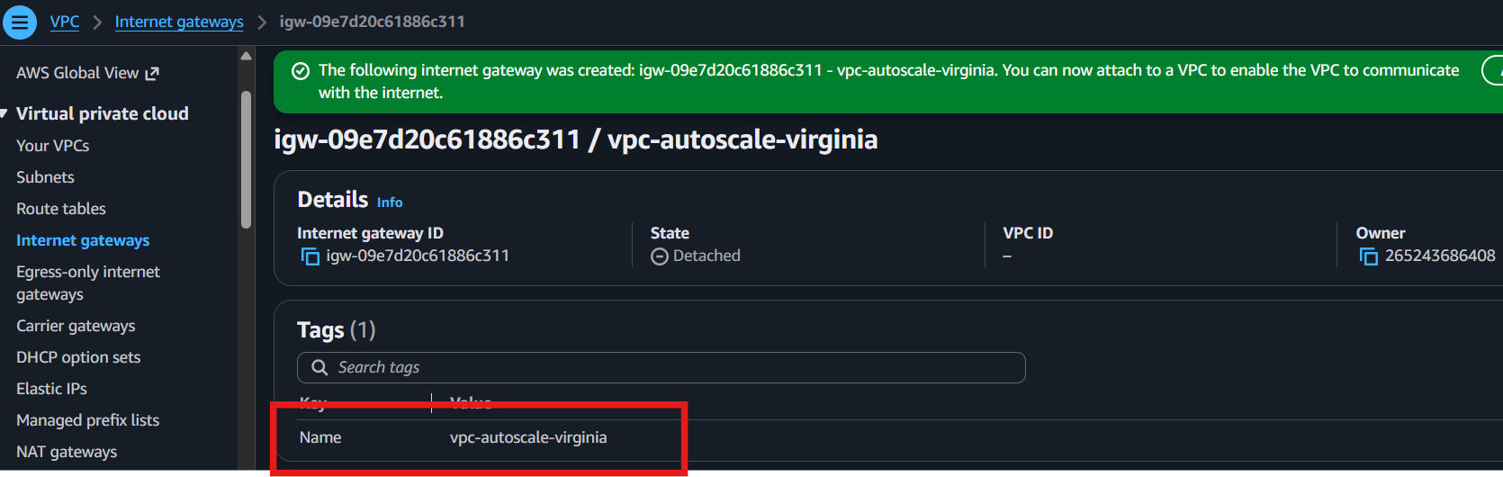
- Select the IGW.
- Click Actions → Attach to VPC.
- Choose your VPC.
- Click Attach internet gateway.
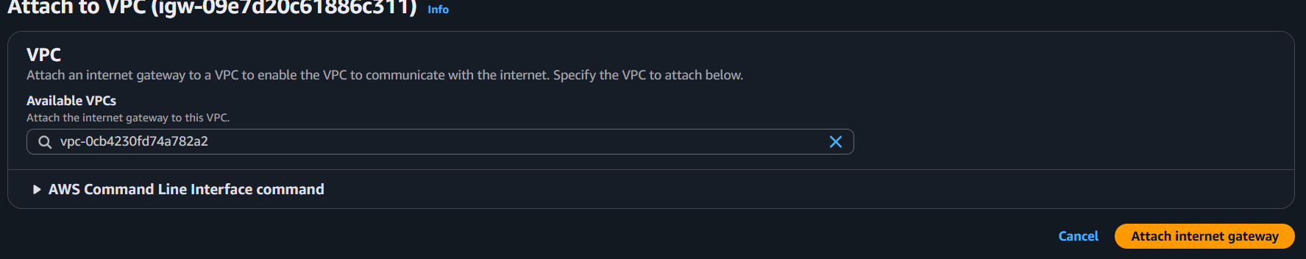

- Create one public route table (RT) and one private route table.
Create a Public Route Table
- Go to VPC → Route Tables.
- Click Create route table.
- Enter Name: Public-RT.
- Select your VPC.
- Click Create route table.
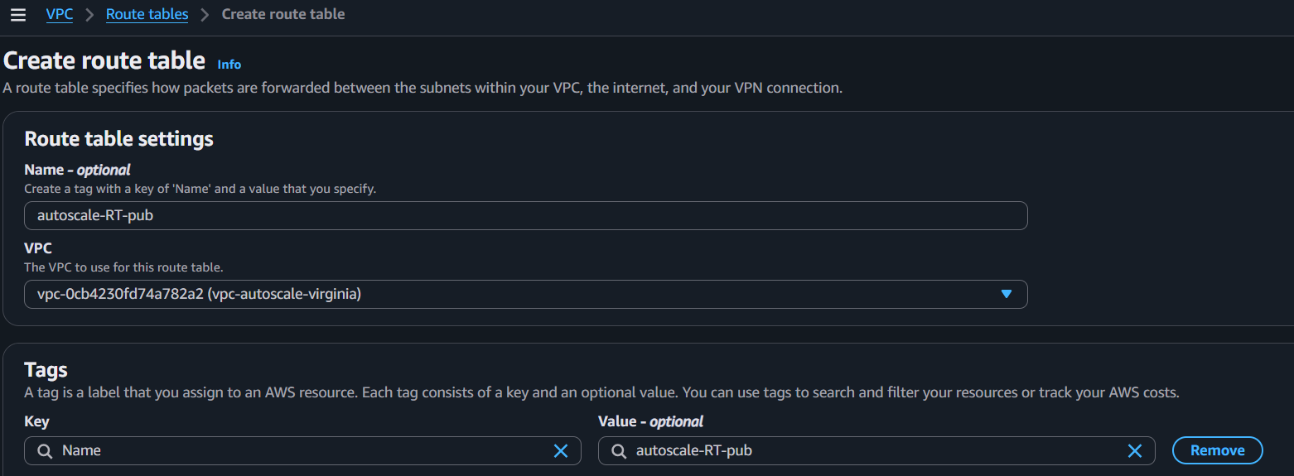

Create a Private Route Table
- Click Create route table again.
- Enter Name: Private-RT.
- Select the same VPC.
- Click Create route table.
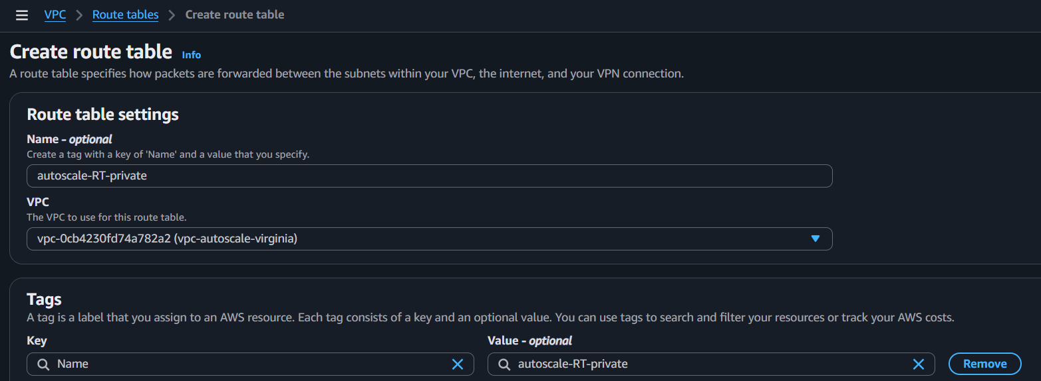

- Deploy a NAT gateway in the public subnet and attach the NAT gateway to the private subnet.
Deploy a NAT Gateway
- Go to VPC → NAT Gateways.
- Click Create NAT Gateway
- Enter Name: autoscale-ngw
- Select the Public Subnet.
- Click Allocate Elastic IP.
- Click Create NAT Gateway.
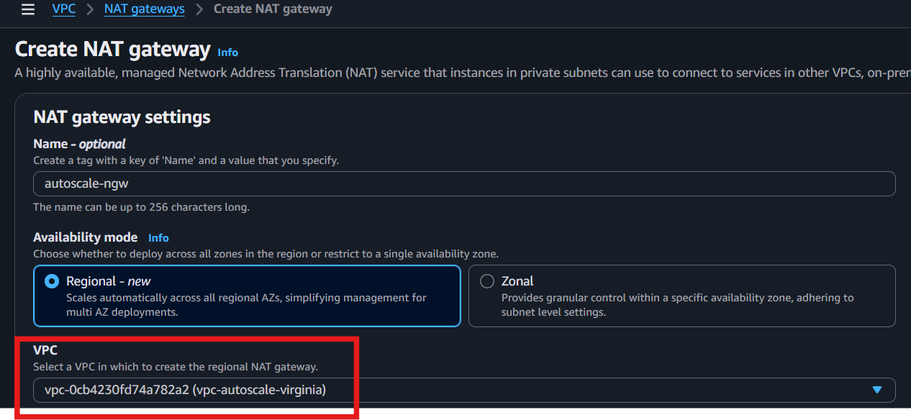
- Wait until the status becomes Available.

Attach the NAT Gateway to the Private Subnet
- Go to VPC → Route Tables.
- Select Private-RT.
- Go to the Routes tab → Edit routes.
- Click Add route.
- Destination: 0.0.0.0/0
- Target: Select the NAT Gateway.
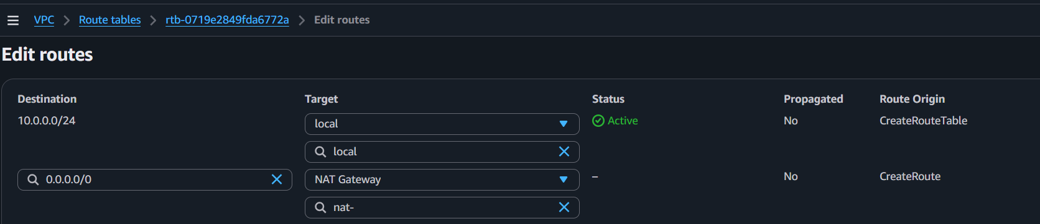
- Click Save changes.

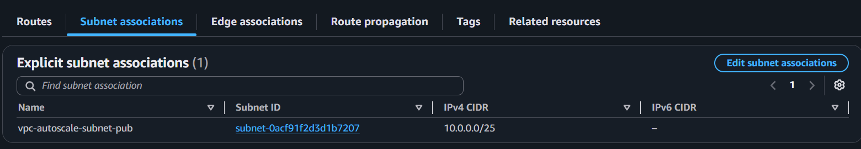
- Associate the Private-RT with the Private Subnet (if not already associated).

- Create two instances, one in the public subnet and one in the private subnet.
Public EC2 Instance
- Go to EC2 → Launch Instance.
- Enter Name: Public-EC2.
- Choose Amazon Linux 2023 (or your preferred AMI).
- Select Instance type: t2.micro (or t3.micro if eligible).
- Select/Create a Key Pair.
- Select your VPC.
- Select the Public Subnet.
- Enable Auto-assign Public IP.
- Select the Security Group (allow SSH/HTTP if needed).
- Click Launch Instance.
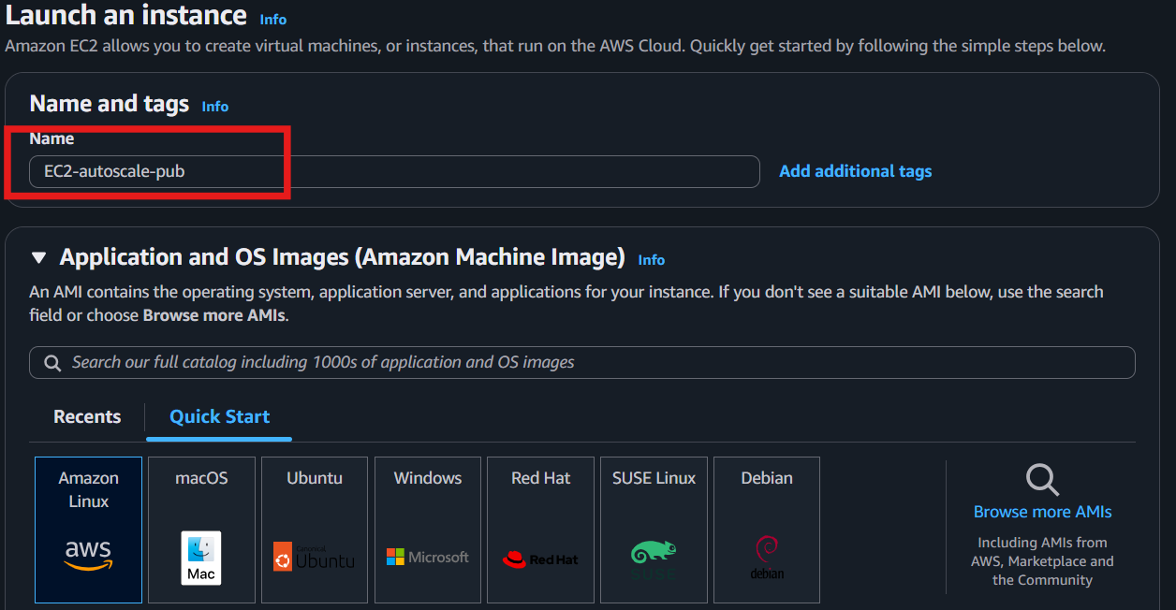
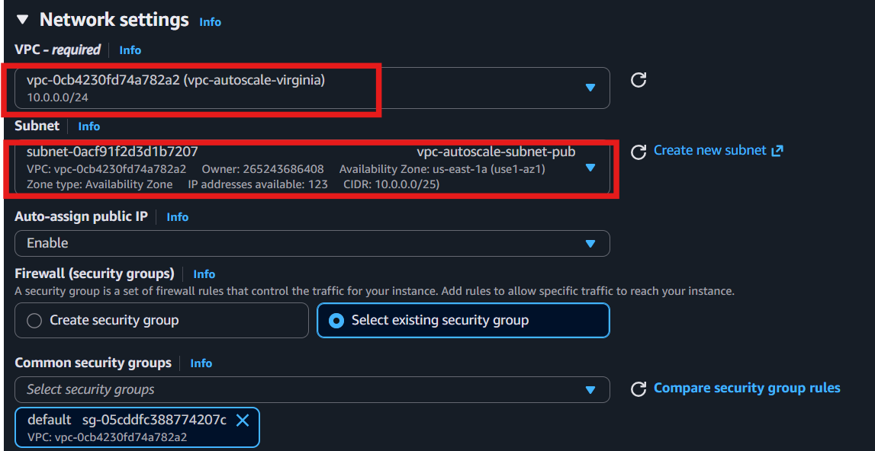

Private EC2 Instance
- Click Launch Instance again.
- Enter Name: Private-EC2.
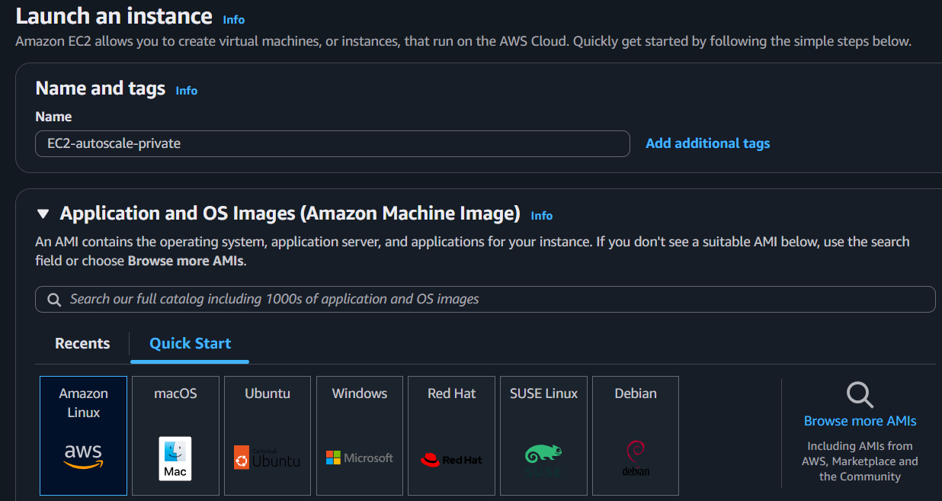
- Choose the same AMI.

- Select Instance type: t2.micro (or t3.micro).
- Select the same Key Pair.
- Select your VPC.
- Select the Private Subnet.
- Disable Auto-assign Public IP.
- Select the Security Group.
- Click Launch Instance.
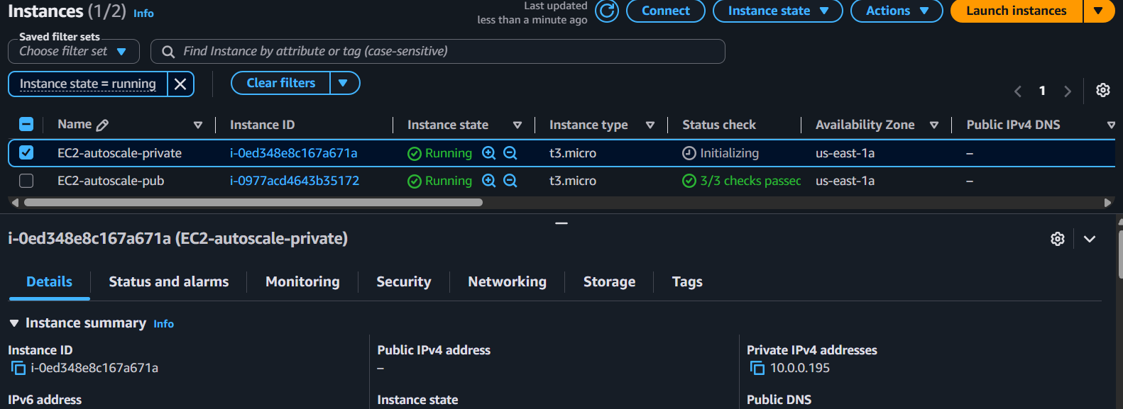

- Deploy Apache server on both EC2 instances with a sample index.html file.
On Public EC2
- Connect to the instance via SSH.
- Install Apache:
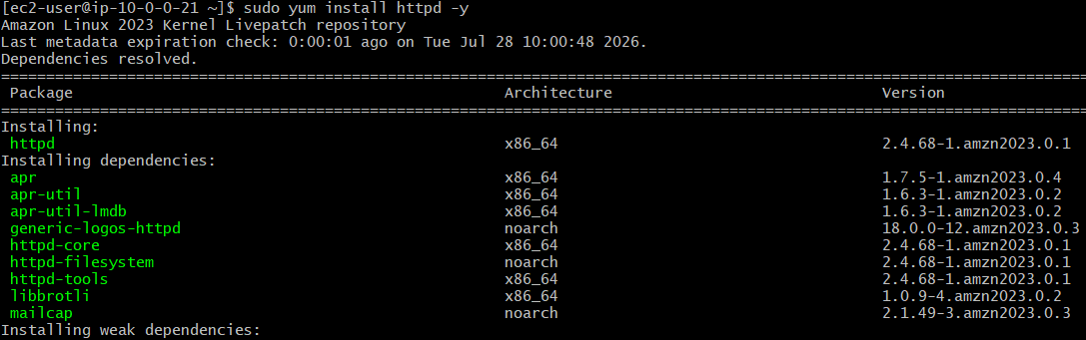
sudo yum install httpd -y

- Start and enable Apache:
sudo systemctl enable --now httpd
- Create a sample web page:
echo "<h1>Public EC2 Apache Server</h1>" | sudo tee /var/www/html/index.html
- Open the Public EC2 IP in a browser to verify.


On Private EC2
- Connect to the instance (via Bastion Host or SSM).
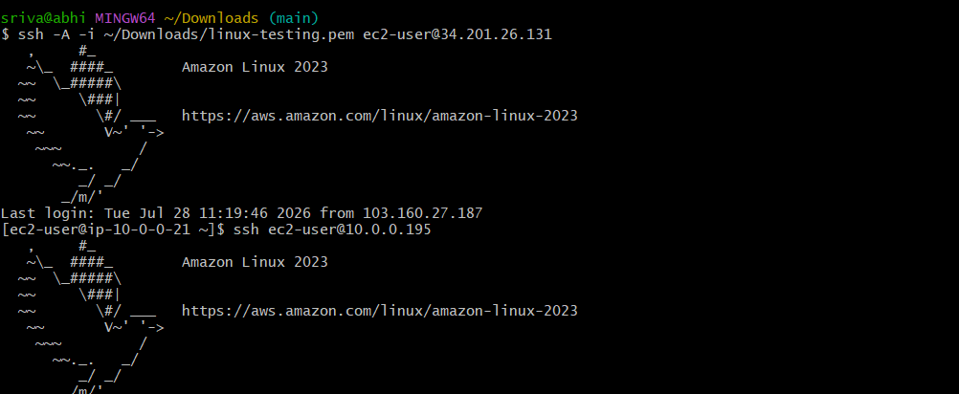
- Install Apache:
sudo yum install httpd -y 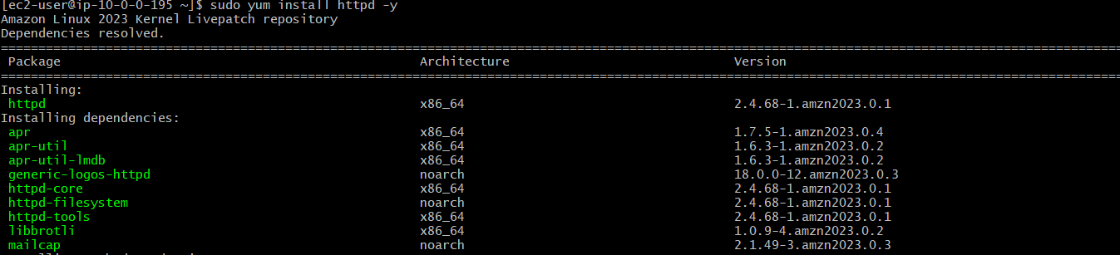
- Start and enable Apache:
sudo systemctl enable --now httpd
- Create a sample web page:
echo "<h1>Private EC2 Apache Server</h1>" | sudo tee /var/www/html/index.html
- Verify locally:
curl http://localhost 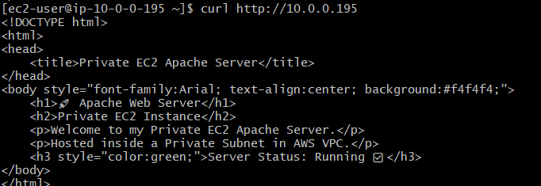

- Create one application load balancer and attach it to both EC2 instances.
- Go to EC2 → Load Balancers.
- Click Create Load Balancer.
- Select Application Load Balancer.
- Enter Name: My-ALB.
- Scheme: Internet-facing.
- IP address type: IPv4.
- Select your VPC.
- Select 2 Availability Zones and choose the Public Subnets.
Note: subnet should be different AZ
- Select or create a Security Group (allow HTTP - Port 80).
- Click Create Target Group.

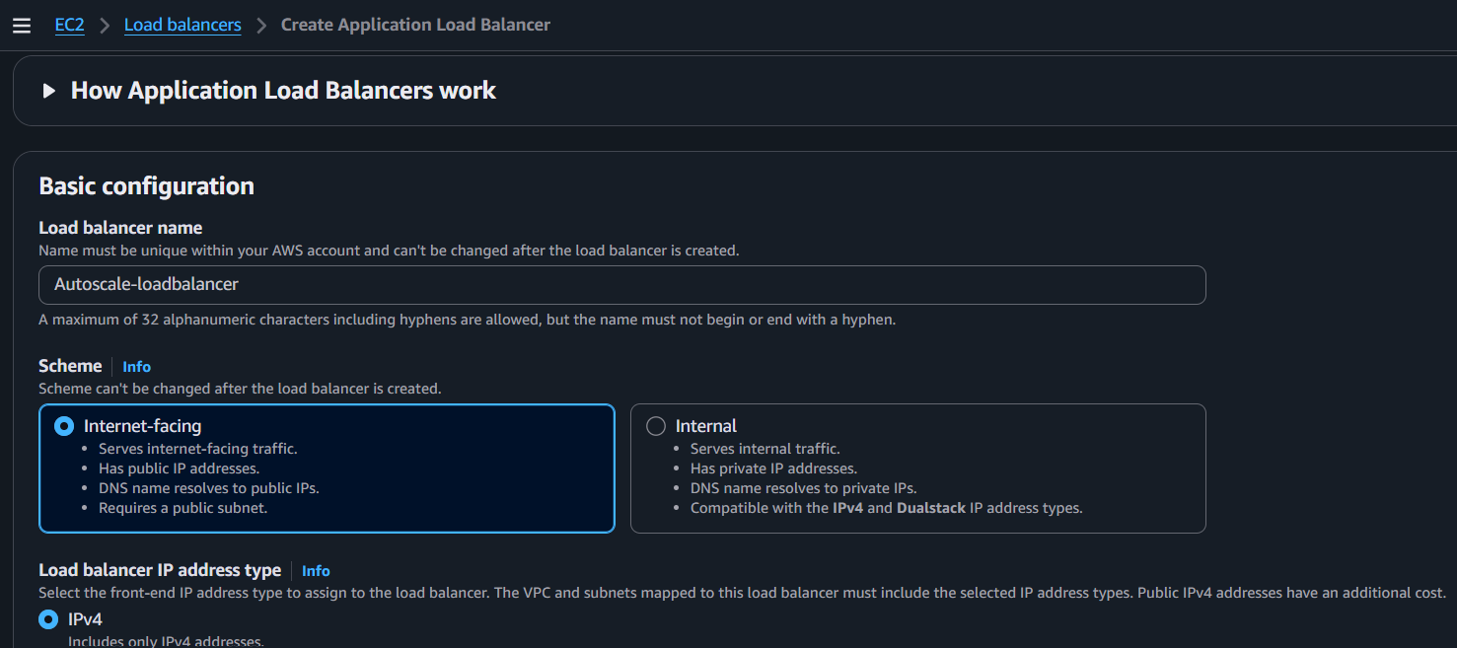

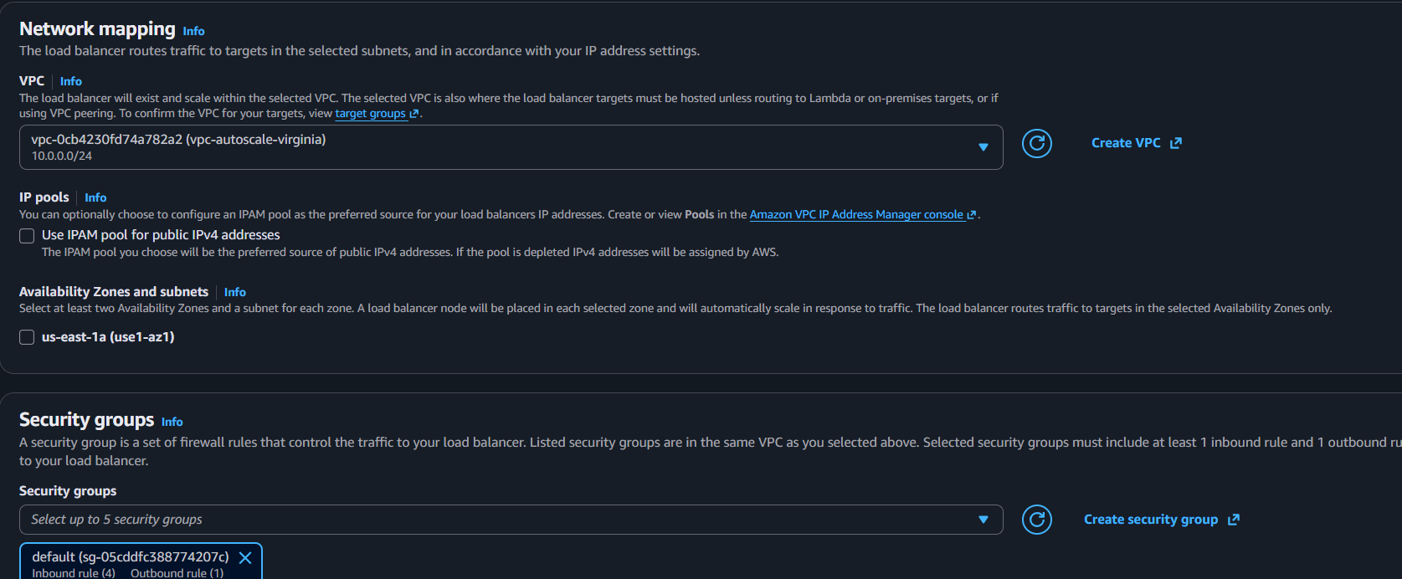
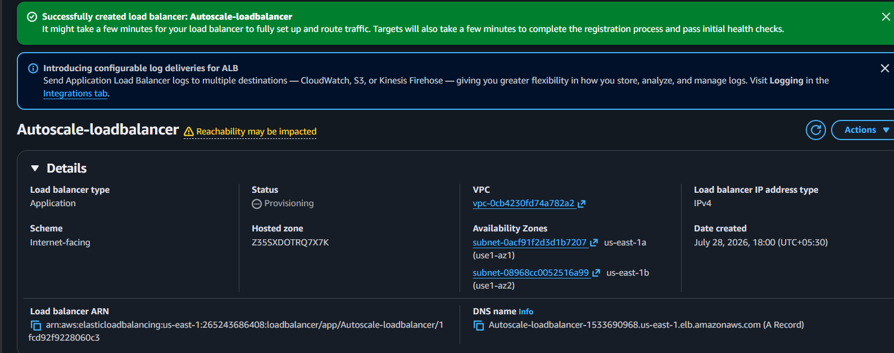
.

- Store application load balancer logs in S3.
- Go to S3 → Create bucket.
- Enter Bucket name (e.g., alb-access-logs-demo).
- Leave default settings → Create bucket.
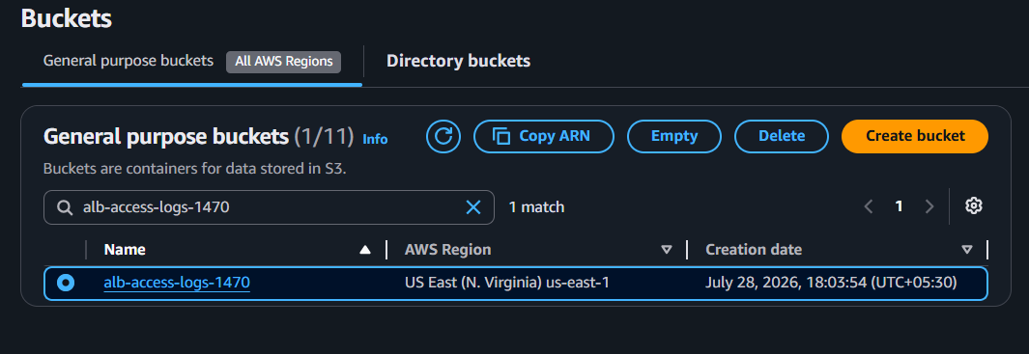
- Go to EC2 → Load Balancers.
- Select your Application Load Balancer.
- Go to Attributes → Edit.
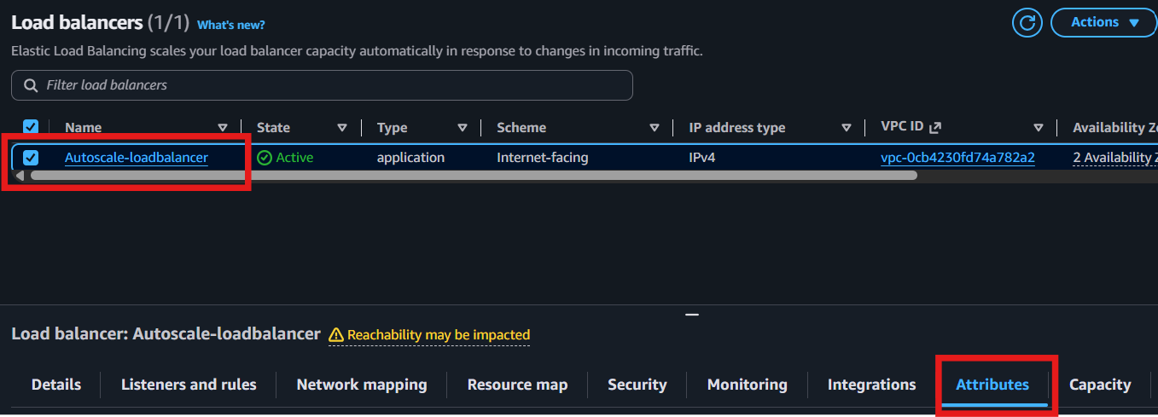
- Under Access logs:
  - ✅ Enable Access logs
  - Select your S3 bucket
  - (Optional) Enter a Prefix like alb-logs/
Note: If AWS shows a permission error when enabling logging, add the required bucket policy to allow the Elastic Load Balancing service to write log files to your S3 bucket.

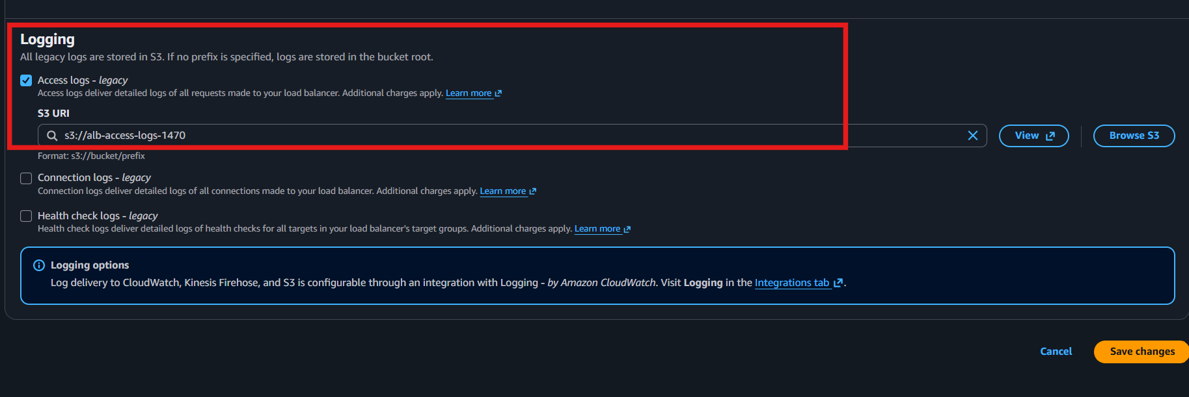
- Click Save changes.
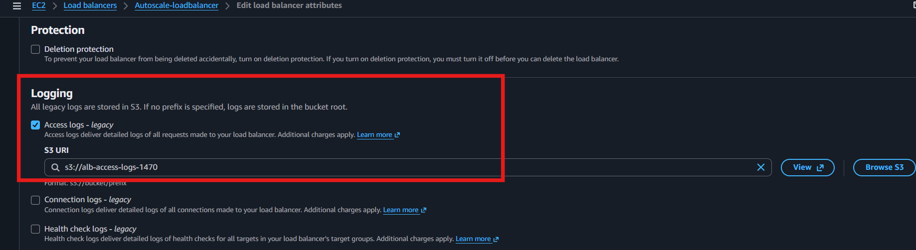
- Generate some traffic to the ALB by opening its DNS name in your browser a few times.

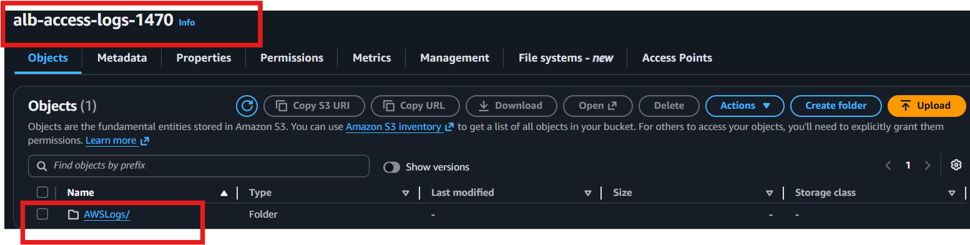
- Go to S3 → Open your bucket → Check for log files under the prefix (or in the bucket root if no prefix was used).

- Store the VPC flow logs in a CloudWatch log group.
- Go to CloudWatch → Logs → Log Groups → Create Log Group and create a log group
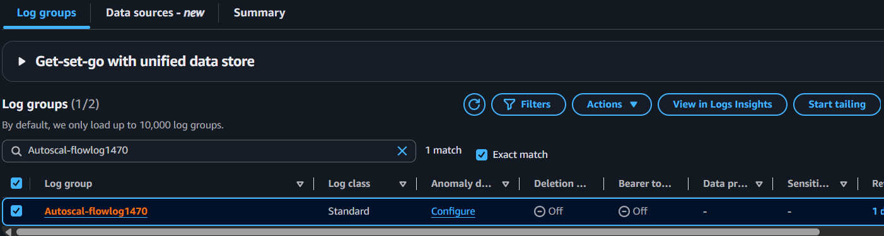
- Create an IAM Role for VPC Flow Logs with CloudWatch Logs permissions.
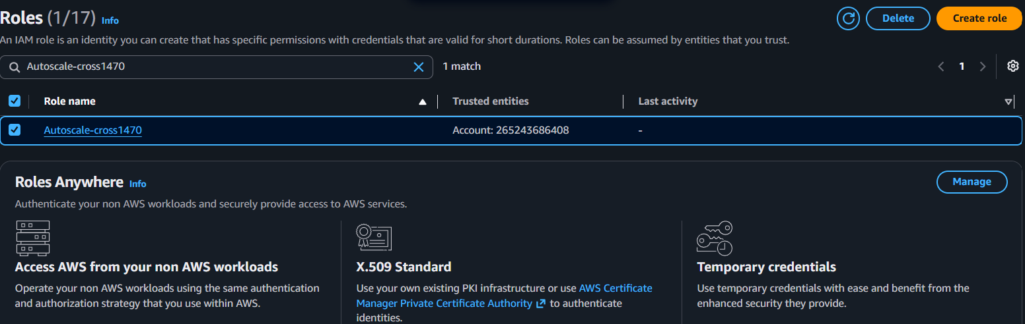
- Go to VPC → Your VPC → Actions → Create Flow Log.
- Select:
- Filter: All
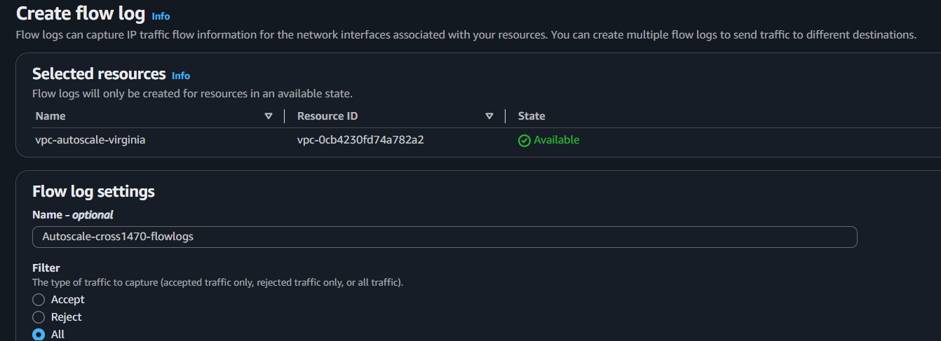
- Destination: Send to CloudWatch Logs
- Log Group: VPCFlowLogs
- IAM Role: Select the created role
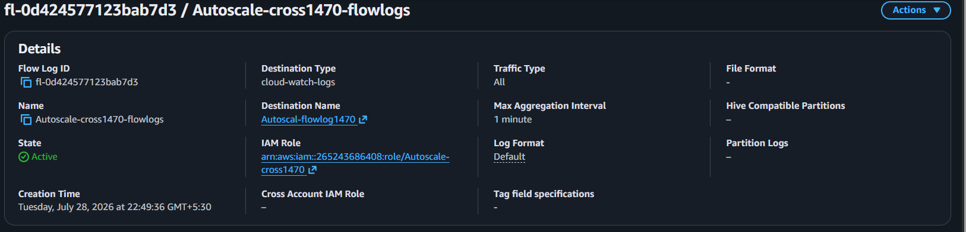
- Click Create Flow Log.
- Verify logs in CloudWatch → Log Groups → VPCFlowLogs.

- Create monitoring dashboards to monitor CPU utilization and to monitor the Apache service.
- Open CloudWatch → Dashboards.
- Click Create Dashboard.
- Enter Dashboard Name (e.g., EC2-Apache-Monitoring) → Create.
- Click Add Widget → Select Line.
- Choose EC2 → Per-Instance Metrics → Select CPUUtilization → Create Widget.
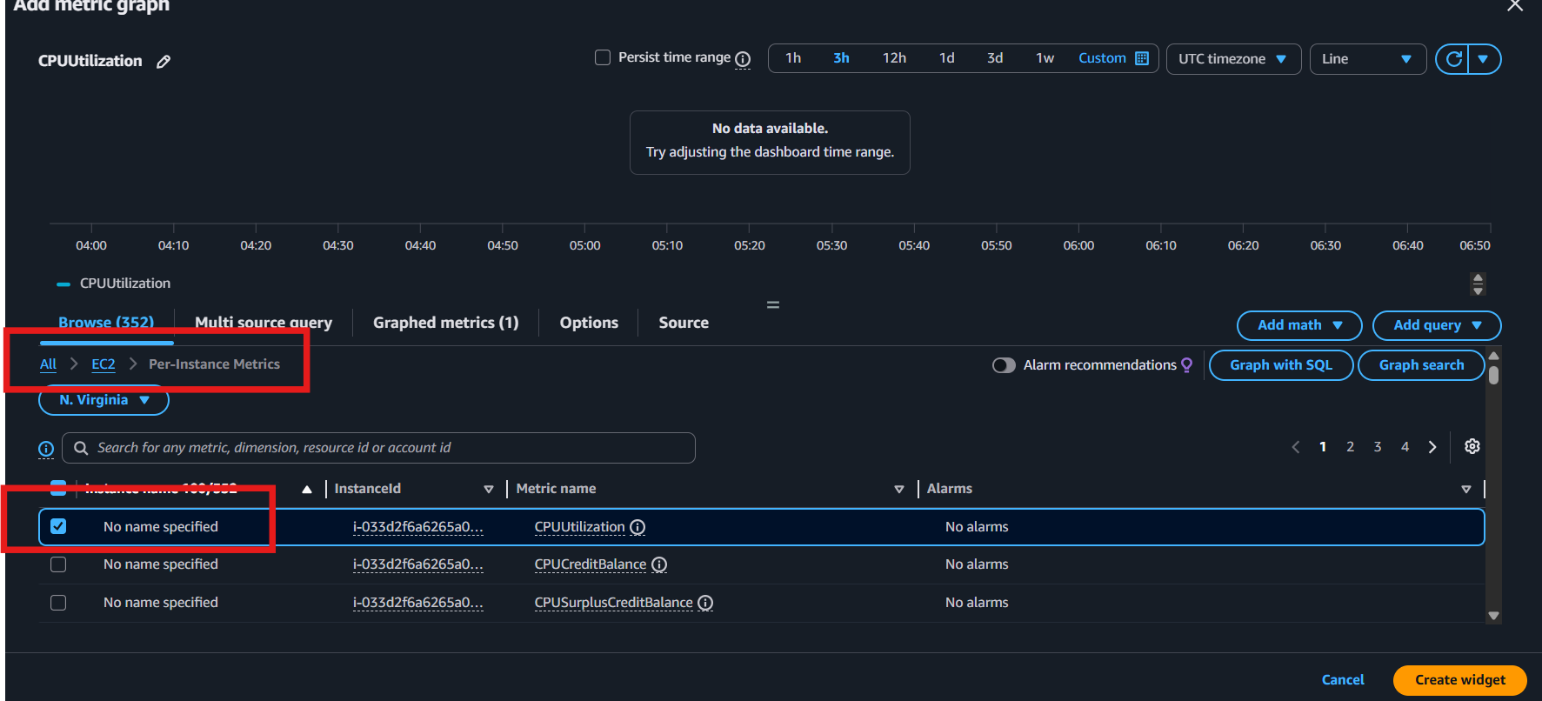
- Click Add Widget again → Select Line.
- Choose CWAgent → Select procstat_lookup_pid_count (Apache/httpd process) → Create Widget.
- Click Save Dashboard.
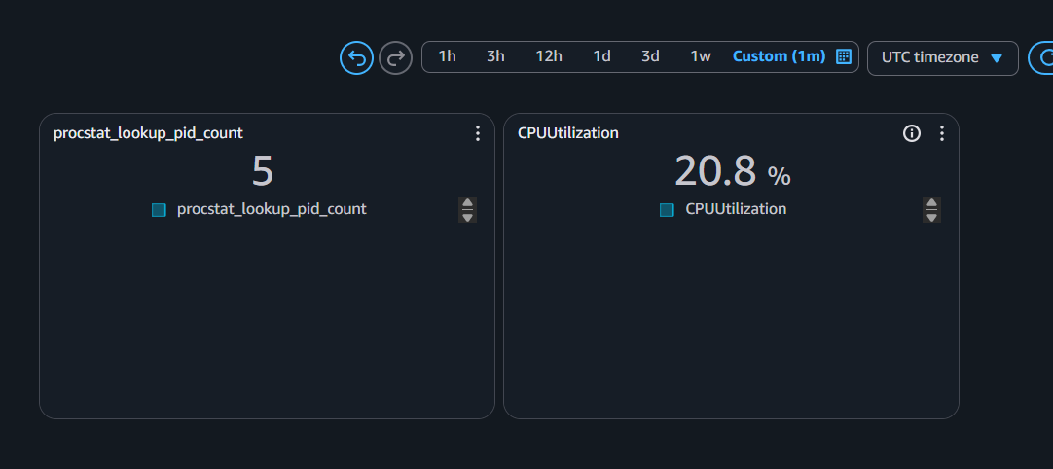

Result:
- CPU Utilization widget monitors EC2 CPU usage.
- Apache Service widget monitors whether the Apache (httpd) process is running.

- If CPU utilization is more than 70%, then it should trigger auto scaling and launch new instance.
Step 1: Create a Launch Template
- EC2 → Launch Templates
- Create launch template
- Select AMI, Instance Type, Key Pair, Security Group
- Add User Data (if required)
- Click Create
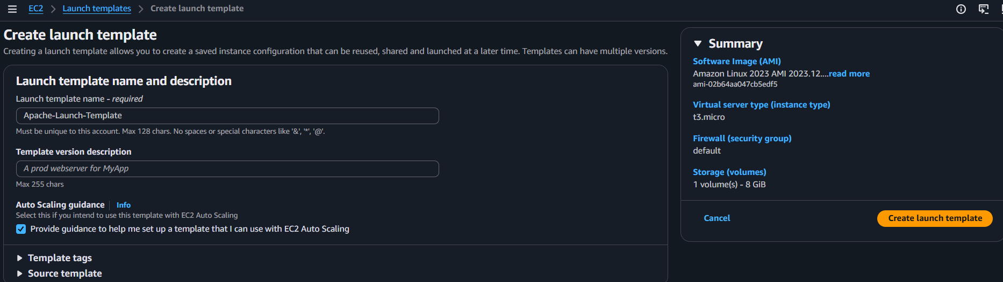
Step 2: Create an Auto Scaling Group (ASG)
- EC2 → Auto Scaling Groups
- Click Create Auto Scaling Group
- Select the Launch Template
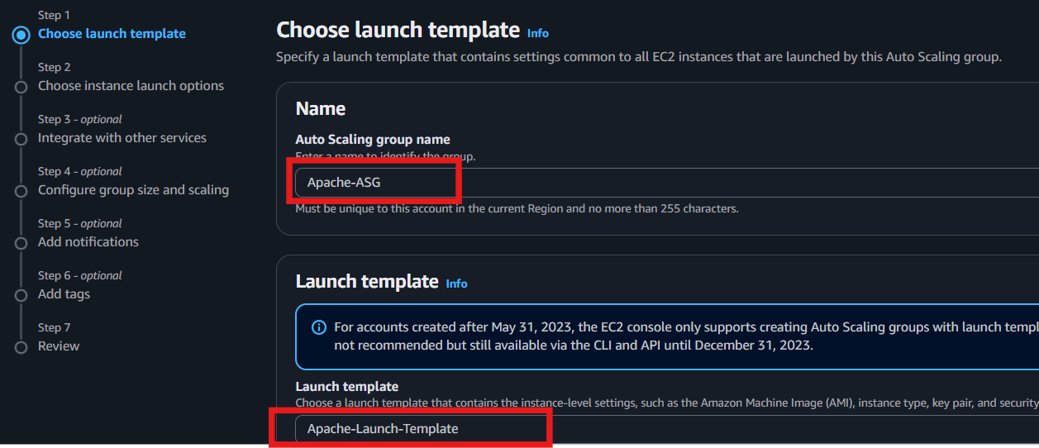
- Choose VPC and 2 Public Subnets (2 AZs)
- Set:
  - Desired Capacity: 1
  - Minimum Capacity: 1
  - Maximum Capacity: 2 (or more)

Step 3: Attach the Load Balancer
- Select Attach to an existing Application Load Balancer
- Choose your Target Group
- Click Next
Step 4: Configure Scaling Policy
- Select Target Tracking Scaling Policy
- Metric: Average CPU Utilization
- Target Value: 70%
- Click Next → Create Auto Scaling Group
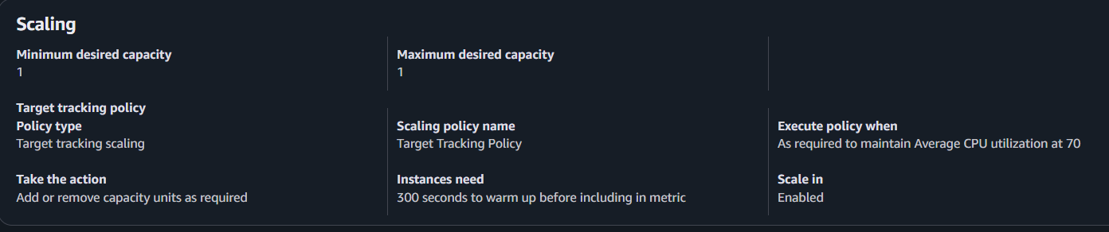
Note: If your assignment specifically says "If CPU utilization is more than 70%", your instructor may expect a Simple Scaling Policy instead of Target Tracking.
Simple Scaling Policy (Threshold >70%)
- Open the Auto Scaling Group.
- Go to Automatic Scaling → Create Dynamic Scaling Policy.
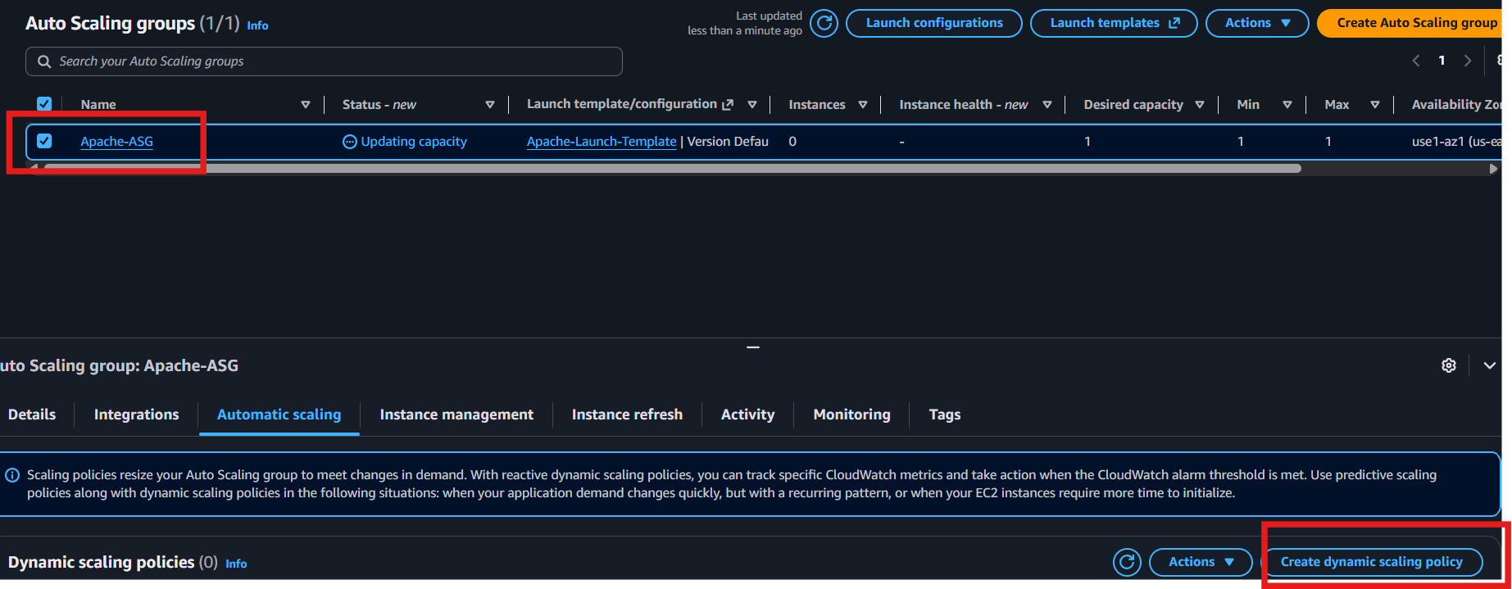
- Policy Type: Simple Scaling.
- Action: Add 1 instance.
- Create a CloudWatch Alarm:
  - Metric: CPUUtilization
  - Threshold: Greater than 70%
  - Period: 1 minute
  - Evaluation Periods: 1
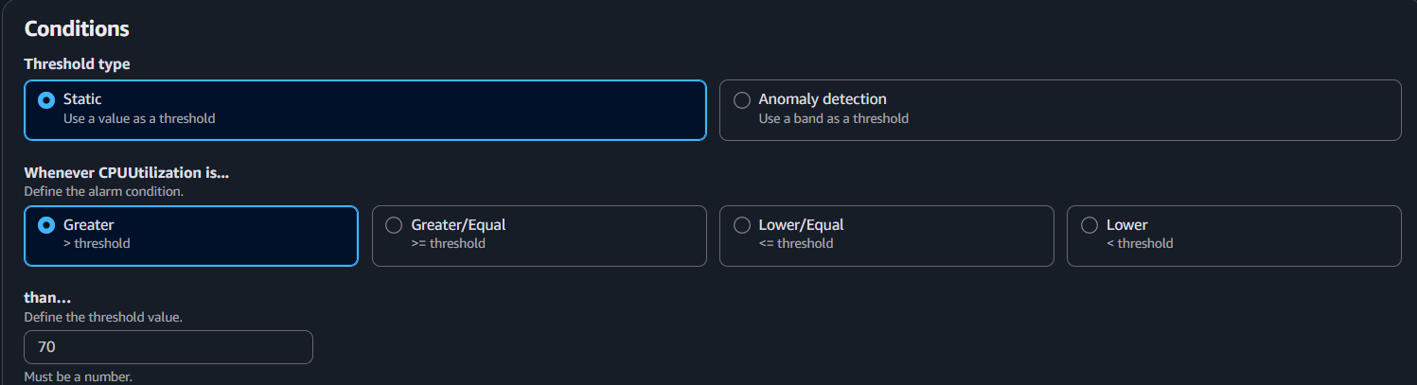
- Save the policy.
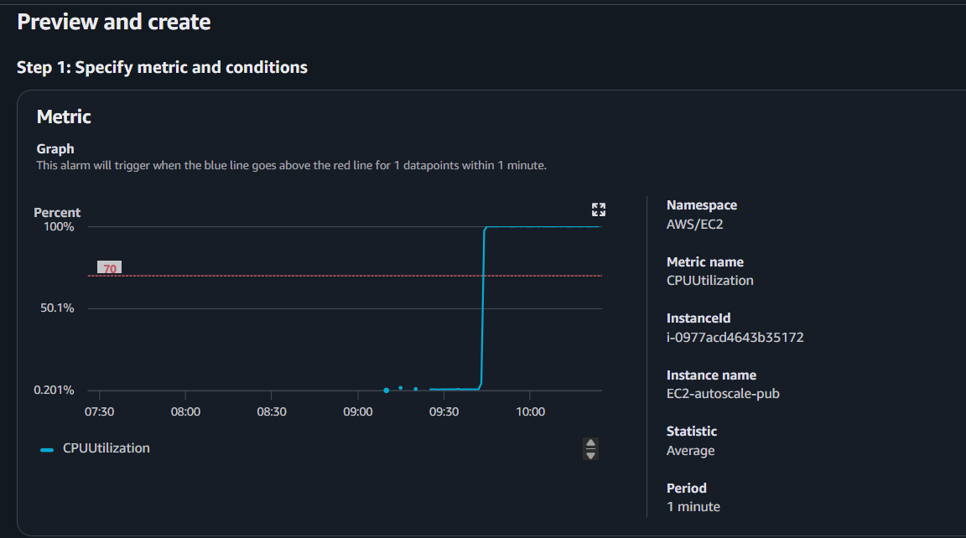
Step 5: Test Auto Scaling
- Generate CPU load on the EC2:
stress --cpu 2 --timeout 300
- Wait 2–5 minutes.
- Verify a new EC2 instance launches in the Auto Scaling Group.
